CURRICULUM.
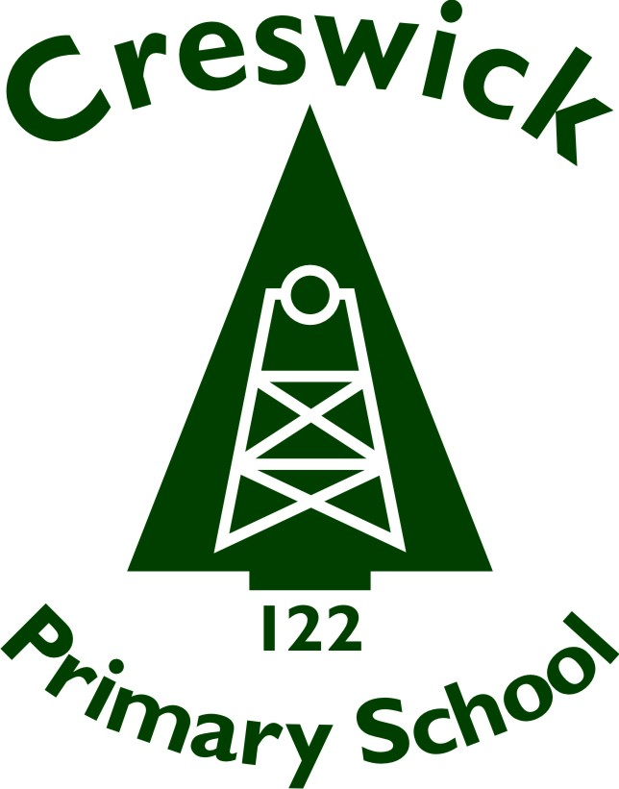
Rationale
The curriculum at Creswick Primary School covers all the arrangements the school makes for students’ development and learning. It includes the course content, student activities, teaching approaches, the way in which teachers and classes are organised and decisions on the need for and the use of facilities and resources.
Creswick Primary School encourages its students to strive for excellence in all of their endeavours. To achieve this, the school provides sequential teaching and learning programs that deliver a comprehensive, broadly based and inclusive curriculum.
Each year the school will map out its planning in the form of a Curriculum Planning document developed at the end of each term in readiness for the following term.
Creswick Primary School will meet the standards with:
- A time allocation for each of the learning areas
- Termly/Weekly Curriculum Planning documents
- A documented strategy to improve student learning outcomes (found within the School Strategic Plan)
Aim
Creswick Primary School will recognise and respond to diverse student needs when developing its Curriculum Programs and Curriculum Plan. The school will provide a variety of programs that will address the specific needs of students in relation to gender, special learning needs, disabilities and impairments, giftedness and students from language backgrounds other than English.
In developing its Curriculum Plan the school will provide a broad range of educational pathways to ensure improved student outcomes.
Creswick Primary School will comply with all DET guidelines about the length of student instruction time required in Victorian schools. The school will provide 25 hours student instruction time per week when developing its Curriculum Plan. The DET requirements related to the teaching of Physical and Sports Education, LOTE, Visual and Performing Art and EAL will continue to be implemented. The use of Digital Technologies will be integrated across the curriculum to support the improvement of teaching and learning outcomes.
Creswick Primary School will continue to improve, implement and evaluate the Early Years and Middle Years schooling approaches from Foundation to Year 6.
Creswick Primary School will embed wellbeing in learning experiences by aligning the student engagement and wellbeing policies. It will also implement The School Wide Positive Behaviour Framework supported by the Resilience, Rights and Respectful Relationships DET program to create an educational environment that is inclusive and meaningful to all students.
Guidelines
The Victorian Curriculum will be used as a framework for curriculum development and delivery at Foundation to Year 6 in accordance with DET policy and guidelines.
- Creswick Primary School will comply with all DET guidelines about the length of student instruction time required in Victorian schools.
- The DET requirements related to the teaching of Physical and Sports Education, LOTE, Visual and Performing Art and EAL will continue to be implemented.
- Creswick Primary will recognise and respond to diverse student needs when developing its curriculum programs and curriculum plan. The school will work in partnership with DET and the Koorie community to provide suitable programs and resources to support the delivery of high quality schooling education.
- There will be a broad offering of programs to meet the demands of students to enhance effective learning for the 21st century.
- School curriculum programs are designed to enhance effective learning and increase student outcomes.
- The Leadership Team will determine the curriculum program for the following year, based on student demand and the needs of the school’s Curriculum Plan to maintain balance. The Leadership Team will meet regularly to track whole school data and identify potential curriculum areas that required focus and to improve student outcomes.
- Every term PLC teams will do a review of the terms planning, audit against the Victorian Curriculum standards to inform future curriculum planning.
- Preparation of our students for the transition from kindergarten to Primary School, Year Levels and Primary to Secondary School is implemented.
- Teaching and learning programs will be resourced through Program Budgets.
- Creswick Primary School will provide an integrated and comprehensive curriculum approach that incorporates the personal and social issues of students into their daily learning experiences by developing, implementing and evaluating the School’s Wellbeing and Social Skills Programs.

Implementation
The Victorian Curriculum will be used as a framework for curriculum development and delivery at Foundation to Year 6 in accordance with DET policy and guidelines.

Review period
This policy was reviewed in June 2021 and is scheduled for review in June 2024

